
POSITIVE PAY NOTIFICATIONS

City Bank’s Positive Pay notifications are available via email and SMS for all Positive Pay clients.
- SMS Number: 86434
- Email: positivepay@send.city.bank
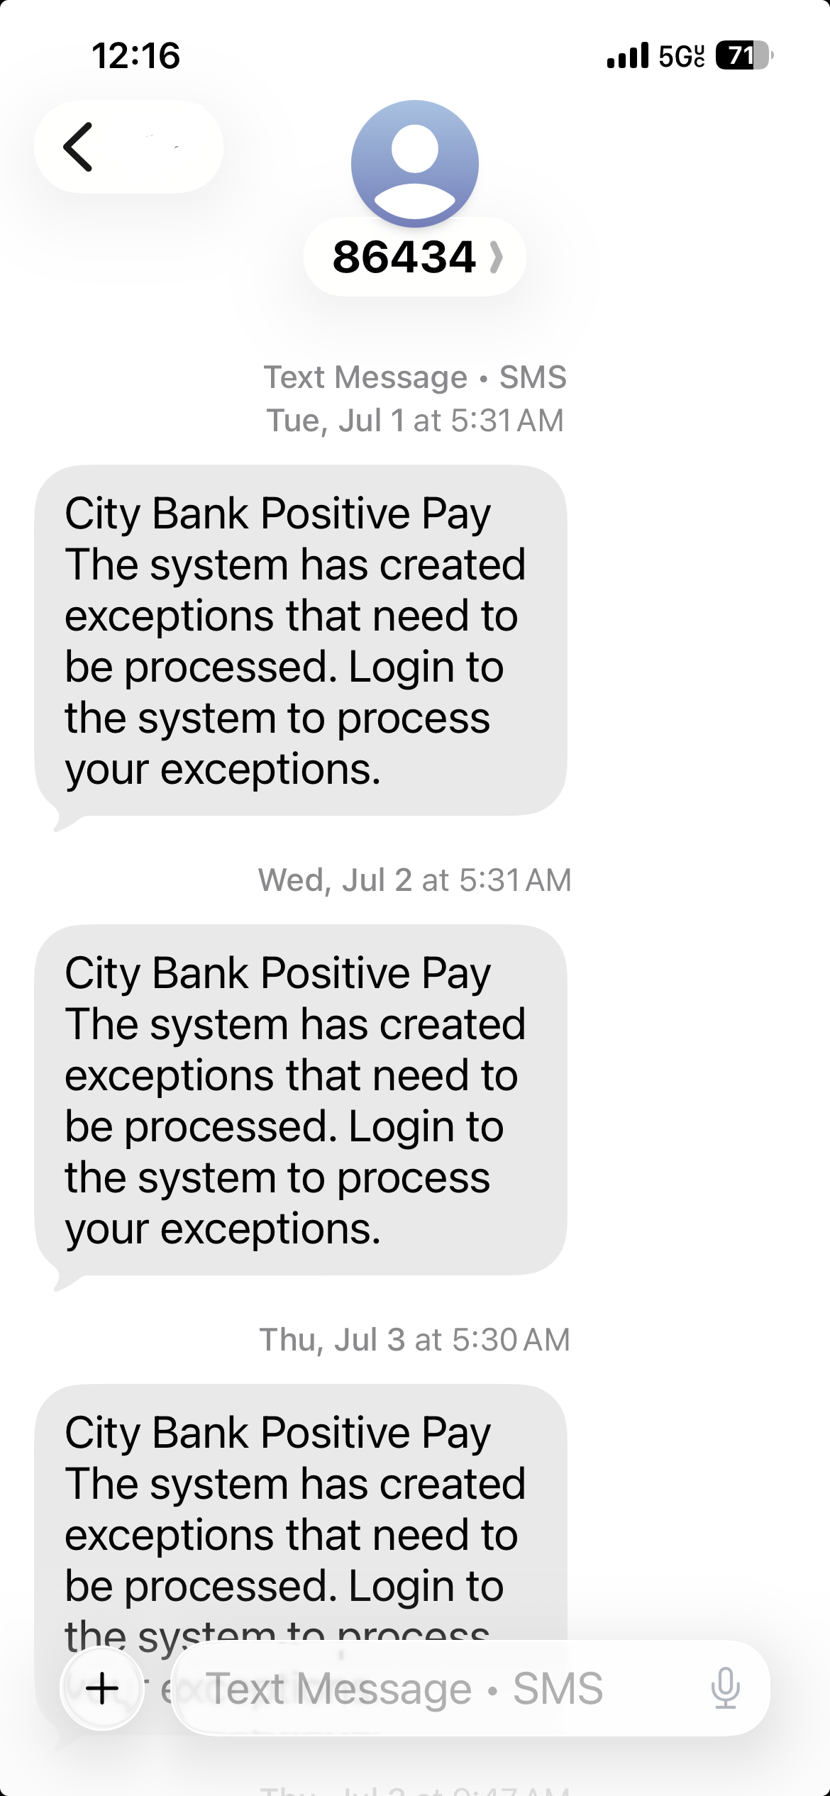
New ACH and/ or Check Exceptions: Notice delivered before 8:00 AM CST
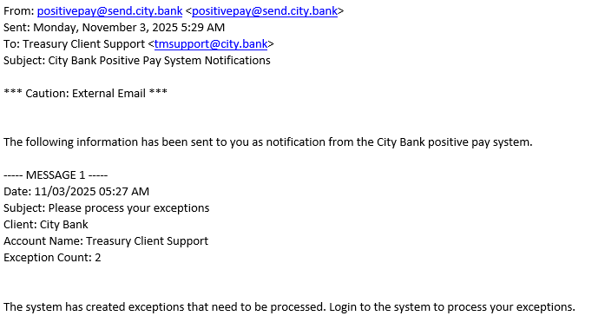

Decision Reminders: Notice delivered at 1:00 PM CST for outstanding exceptions
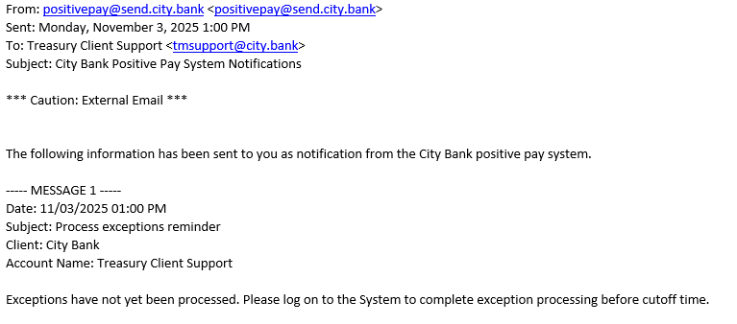
Returned Exceptions: Notice delivered at 2:00 PM CST for returned exceptions
